**Announcement:**

1. **All** the students of **AI group** have to submit the offline on Template Matching.
2. Submission Deadline is **June 23, 2018 11:55 P.M.** Submission link will be created on moodle.

**Instructions:**

1. You have to implement the following template matching algorithms.

* Exhaustive search
* 2D logarithmic search
* Hierarchical search

1. Sample reference image and test image are given below (Image 1 and Image 2). If your algorithm finds the reference image in the test image, report the coordinate of point P in the test image. Point P is shown in **Image 3**.
2. Your code will take the filenames (reference and test images) as input and coordinate in test image as output. **Also report the time required by your algorithms.**
3. Several test and reference images will be given. Try to accomodate all possible corner cases.
4. Implement your code in **Python**. Try to do it yourself. **Copy-checker** will be applied to your codes. Negative mark will be given to both source and destination for copy.
5. Follow the submission guideline of **CSE 410** for this sessional also.



Image 1: Reference Image

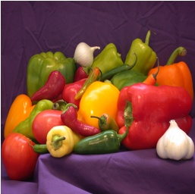

Image 2 : Test Image

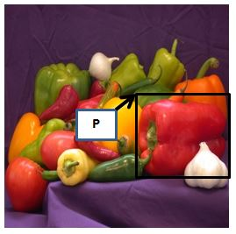

Image 3